**Coursera Capstone Project**

**The Battle of the Neighborhoods - Week 1**

Nelizza Anne Arrojo Enriquez

# Introduction and Data Section

## 1. Introduction

### 1.1 Scenario

I have friend who lives in Singapore, she has been offered by her employer to relocate to Manhattan NY. She is very excited about it but she is also hesitant because she loves her current residence in Singapore and doubts she will find a similarly convinient place in NYC.

She lives within walking distance to an MRT metro station, different kinds of restaurants, cafes, shop and many kinds of entertainment.

I am excited for this opportunity to help my friend find a place in NY similar to her place in Singapore now while also applying what I learned in the Coursera Applied Data Science Capstone course.

### 1.2 Business Problem

**To find an apartment in Manhattan NY that meets the following:**

* 2 or 3 bedrooms
* a metro station within a 1.0 mile radius
* rent: USD7,000 per month
* accesible places: coffee shop, asian restaurants, groceries, gym

### 1.3 Interested Audience

Aside from my friend and me, this study may alse be useful to anyone interested in moving to Manhattan NY. It is also a good reference for anyone wanting to practice and develop their Data Science skills

## 2. Data Section

### 2.1 Data Description

**We need the following data to answer our Business Problem**

* List of Boroughs and neighborhoods of Manhattan with their geodata (latitude and longitude)
* Venues for each Manhattan neighborhood
* List of Subway metro stations in Manhattan with their address location
* List of apartments for rent in Manhattan area with their addresses, price, and details

### 2.2 Data Usage - How the data will be used to solve the problem

**The data will be used as follows:**

* Use Foursquare and geopy data to map top 10 venues for all Manhattan neighborhoods and clustered in groups
* Use foursquare and geopy data to map the location of subway metro stations, explore each subway location to identify venues near each one
* Use Foursquare and geopy data to map the location of rental places
* Make a map that shows average rental price per square ft within a radious of 1.0 mile around each subway station
* Use Nominatim and Geopy-distance to convert addresses from rental locations to geodata
* We will also look for availble open data sources from real estate sites or goverment data

**After we process the data we will be able to asnwer the following questions to help us solve our Business Problem:**

* How much is the cost of rent (per square ft) around a mile radius from each subway metro station?
* Which area of Manhattan has the best rental prices and meets our requirements?
* How venues distribute among Manhattan neighborhoods and around metro stations?
* Any other interesting statistical data findings of the real estate and overall data.

**Reference of venues around current residence in Singapore for comparison to Manhattan place:**

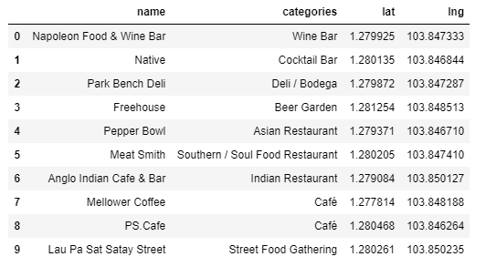

**Map of Singapore with venues near residence place:**

